# Add an Alarm Point Action to an Incident OLA Service Target Procedure

Service Level Management

**Purpose**

Alarm Point notification can be produced by an Incident OLA Service Target when a goal has reached any of the milestones. XMatters will notify the on-call of the group in which the Incident ticket is assigned. The timing of the Alarm Point notification is based on the “Terms and Conditions” and the “Hours / Minutes” that are set up within the Service Target.

**Related Policy**

* [IT Service Management Policy](https://sharepoint.jackson.com/sites/itsmsd/servicelevelmanagement/Shared%20Documents/Pre%20December%202019/SLM%20Documents/Policy%2C%20Process%2C%20Procedures/SLM_Service%20Level%20Management%20Process.doc?d=wa1eaba53e1dc4b30abda2a0886981cc9)

**Audience**

The following groups are responsible for adhering to this document:

* Service Level Management

**Procedure**

|  |  |
| --- | --- |
| Step | Action |
| 1 | To access Service Level Management in Remedy, following the instructions below.   1. Select the Applications tab on the side.      1. Select “Service Level Management” 2. Select “Service Level Management Console”      1. On the “SLM Console” tab, click the “Folders” drop down arrow. 2. Click the “Standard Services” drop down arrow. 3. Select the “Incident OLAs” folder.      1. Click on the “Service Targets” tab. This will show existing OLA Service Targets that have been created. 2. To put the Service Targets in alphabetical order, click “Title” on the blue bar.      1. Select a Service Target and click the “View” button to open it. |
| 2 | To add an Alarm Point Action:   1. Inside the Service Target in which an Alarm Point Action is to be added, click the “Milestones” tab. 2. Under the “Actions” box, click the “Add” button.      1. Click the drop down arrow and select “Custom”. 2. Select “New Push Fields Action”. 3. Click the “OK” button.      1. Enter information in the following fields:  * **Title:** Name the Action “HPD_SetFlag” * **Description:** “Alarm Point” * **Push Value To:** Select “HPD:Help Desk” from the drop down list. * **Push Value If:** 'Incident Number' = $Incident Number$   *See* ***Appendix A*** *to use the Qualification Builder to define the value.*   * **If No Request Match*:** Select “Take No Action” from drop down list * **If Any Requests Match*:** Select “Modify First Matching” request from drop down list. * **Field Name:** Select “PGDS_XM_MGMNT_Notification_Flag” from drop down list. * **Value:** Type “Yes”  1. Click the “Update list” button. The Field Name and Value will appear in the “Field/Value” list”. 2. Click the “OK” button.      1. The Alarm Point Action will appear in the Actions box.      1. Click the “Save” button. |
| 3 | Ensure that the Service Target is “Built Successfully”.   1. After saving the updated Service Target, a prompt will appear to rebuild the Service Target. Click “Yes”. 2. The status of the updated Service Target may say “Build in Progress”. Continue to hit the “Refresh” button until the status changes to “Built Successfully”.      1. If the status changes to “Could Not Be Built”, highlight the updated Service Target and click the “Build” button.      1. In the event the status returns to “Could Not Be Built”, highlight the updated Service Target and click the “View” button. 2. Return to the “Milestones” tab. 3. Highlight the Alarm Point Action that was added. 4. Click the “View” button.      1. Review all of the fields to ensure they are correct. 2. If you are unable to locate any errors within the Alarm Point Action and the Service Target does not change to “Built Successfully”, contact ITSM Suite Administration for assistance. |

**Appendix A – Use Qualification Builder for “Push Value If” Field.**

Use the Qualification Builder to ensure that the “Push Value If” field is set up correctly.

In the Action that is being created:

1. Click the “Define” button



1. Click the drop down arrow next to “Fields From Other From”
2. Select “Incident ID*+” from the drop down list

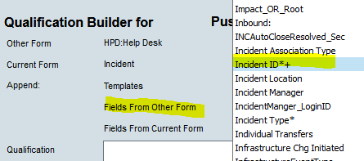

1. Click the drop down arrow next to the “Operators”.
2. Select the “=” sign from the drop down list.



1. Click the drop down arrow next to “Fields from Current Form”
2. Select “Incident ID*+” from the drop down list.

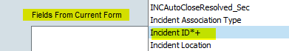

1. This will add the formula to the “Qualification” box.
2. Click the “OK” button.

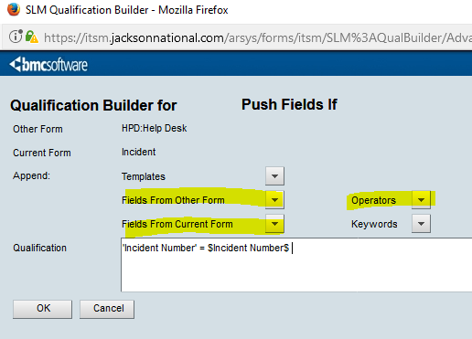

**Modification**

The following associates can make modifications to this document:

* Manager, Service Level Management
* Director, IT Service Management
* Vice President, Service Delivery
* Chief Technology Officer, JET

|  |  |
| --- | --- |
| Service Level Management Process | |
| Responsible Party: Sharla Piepkow, Manager, Service Level Management Approving Authority: Rob Kolm, Director, IT Service Management | Date Created: 10/09/2017 Last Modified: 05/29/2020 Last Reviewed: |